Junwei Xu xu.2300 500065630
Operating system lab1
Part A:
- screenshots showing the execution of 5 different commands:
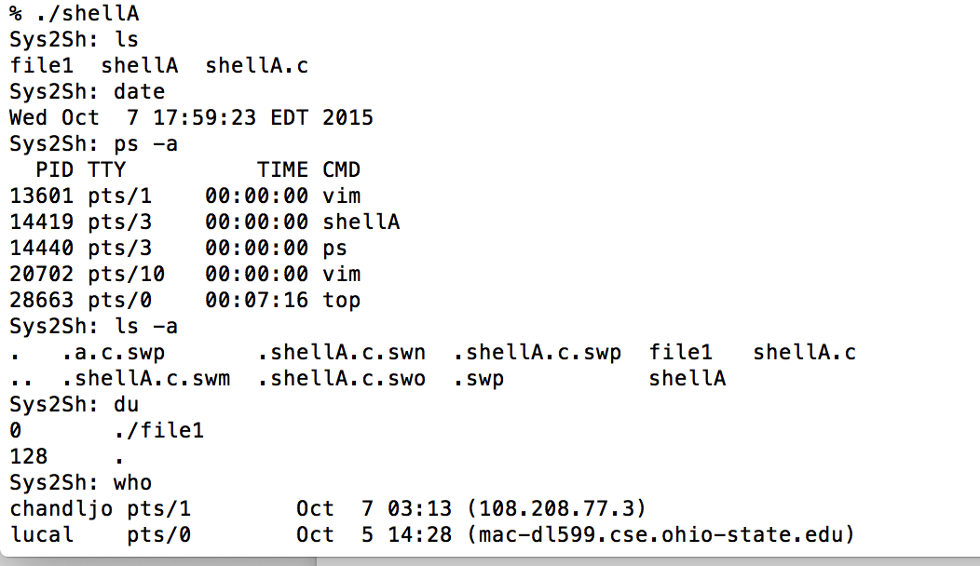

Part B:
Feature 1: History print for 12 most recent commands
At first, we input 14 different commands as follow: ls, ls-a, date, uptime, users, pwd, du, hostname, whoami, ps –a, ps, df, last -5, w. And the screenshots are as followed.
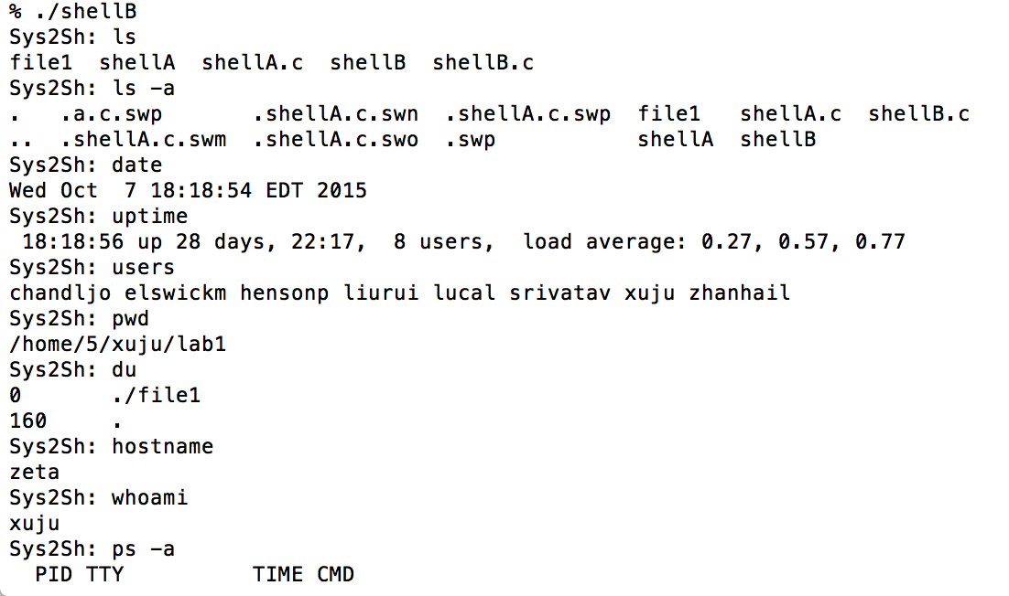
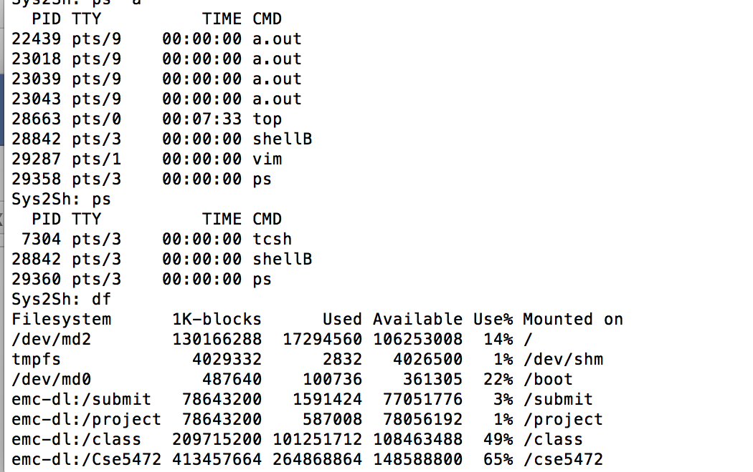

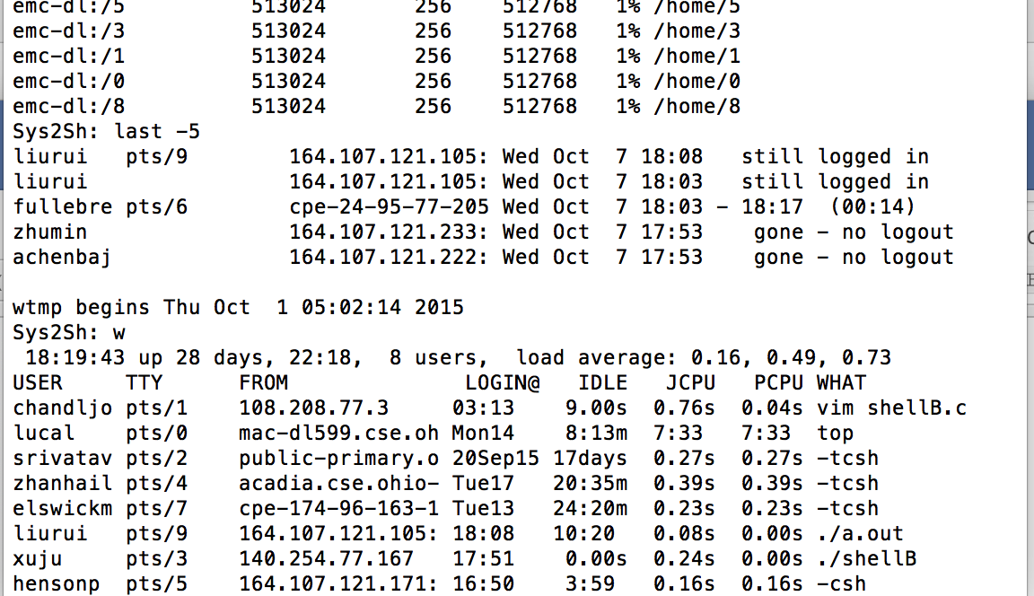
Then print history, we could get the 12 recent history documens:

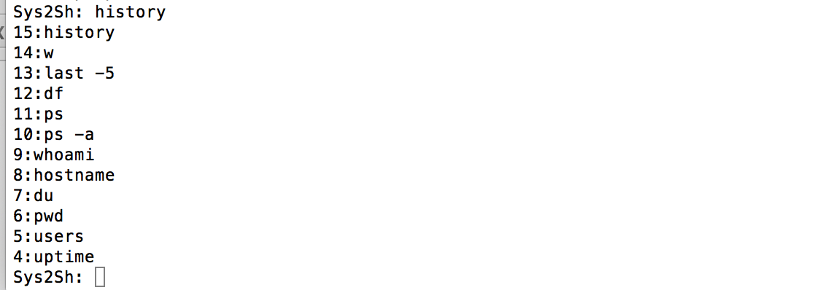
Feature2:Duplicate remove
Then print pwd and ps, and print the history, we could see that because of the duplicate remove, num 6 and num11 history are removed.

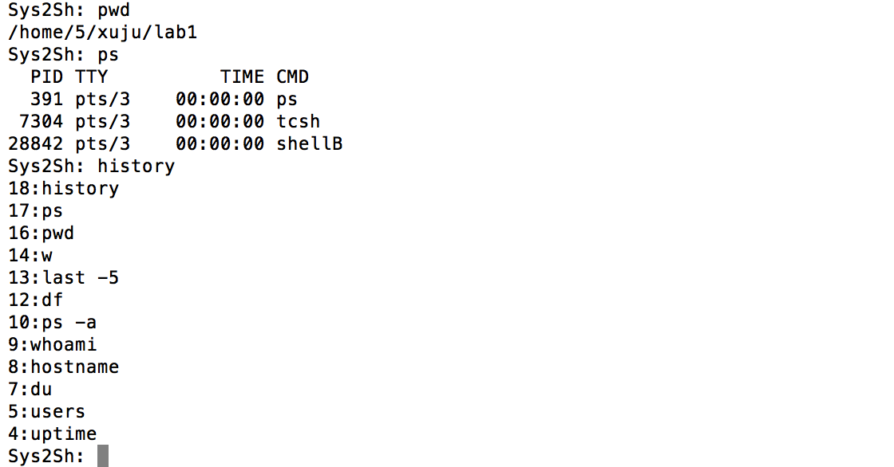

Feature3: r num
Then print r 5, we could see the command of “user” is echoed on the screen, and user is executed. And r 5 is not in the history, and the real command it represents is in the history.And the num 5 history “ user” is removed.

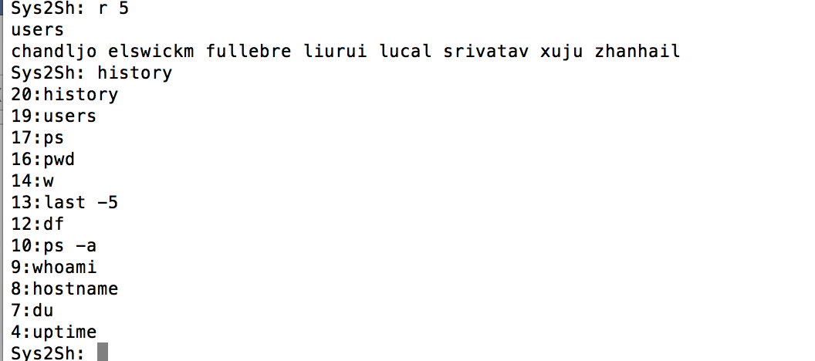

Feature4: rr
Then print ls, then print rr, and the most recent command is executed ---“ls”. And rr is not in the history, and the real command it represents ---- “ls” is in the history.
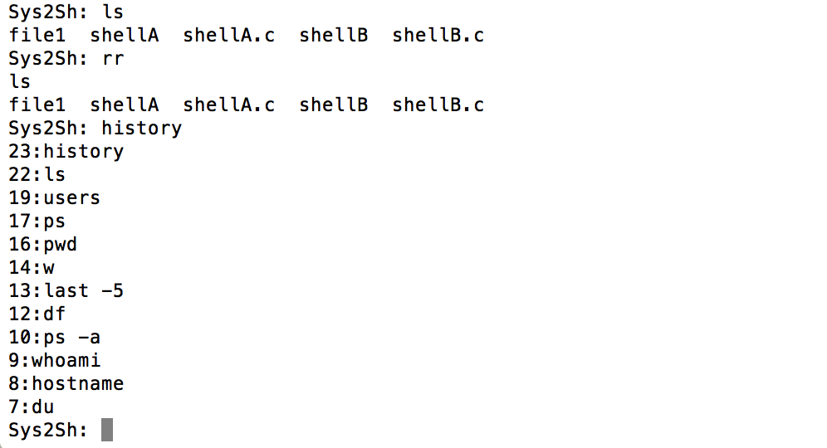
Feature 5: r str
Then print “r ps”, we could see the most recent command that starts with “ps”---- “ps” is executed, and “r ps” does not get into history , but the real “ps” get into the history.

Then print “r last”, we could see the most recent command that starts with “last”----- “last -5” is executed, and “r last” does not get into history the real “last -5” get into the history.
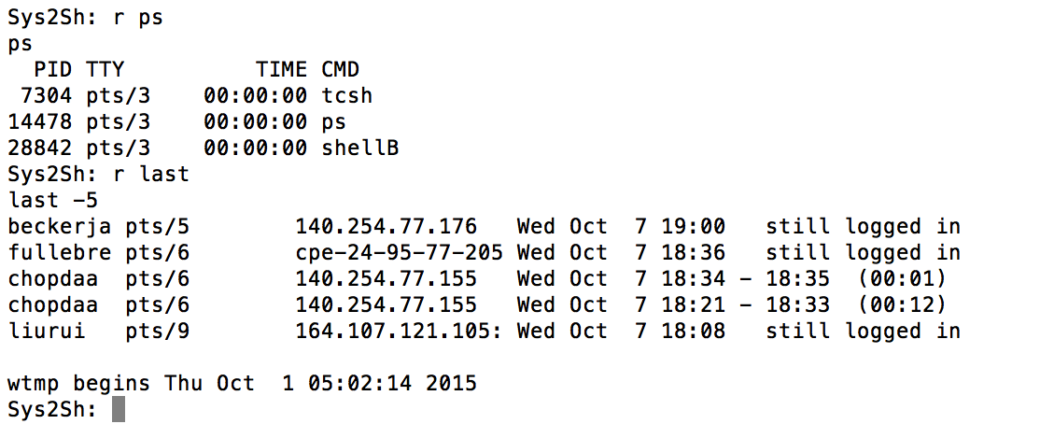
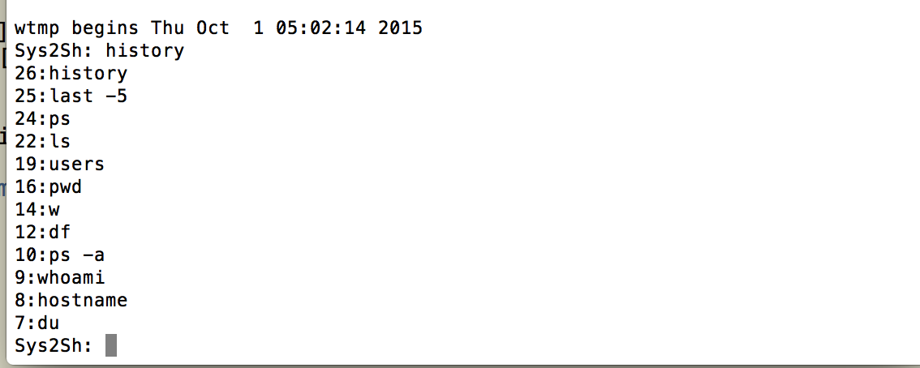

Feature6:sethistory num
Then print “sethistory 5”, then execute “history”, we could see there are only 5 history documents.
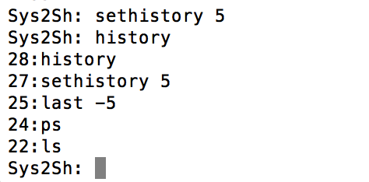

Then print “sethistory 10”, then execute “history” , we could see there are 10 history documents.
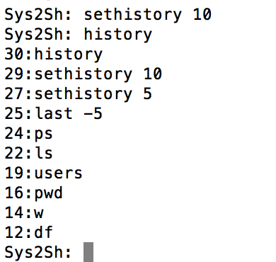

Feature7: Error checking:
Then print “r 44”, then the screen would print: r with number that is not in history.
Then print “r -1”,then the screen would print: r with non- positive number.
Then print “r”,then the screen would print: r with no history number.
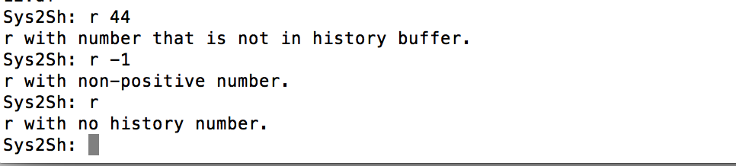

Complete Code:
/*Junwei Xu xu.2300 500065630 lab1 OP*/
#include <stdio.h>
#include <stdlib.h>
#include <unistd.h>

#define MAXLINE 80 /* 80 chars per line, per command, should be enough. */
#define MAXSAVE 100

void execute(char *args[]);/*execute the commmands in childprocess*/
void execute1(char *args[]);/* add commands and duplicates remove in parentprocess */
void addCmd(char *args[]);/* add the commands to the history */
void printHistory();/* print history */
void compare1(char *args[]);/* duplicates remove */
int num(char *args[]);/* caculate the number of "r num and rr" */
int num1(char *args[]);/* sethistory num */
int num2(char *args[]);/* caculate the number in hcmd of "r str" */
void echoScreen(char *args[]);/* show the array on the screen */

struct cmd{
char* av[MAXLINE / 2 + 1];
};

int flag[MAXSAVE]={0};
struct cmd hcmd[MAXSAVE]; /* define the three dimensional array */
int hisNum=0 ; /* define the number of command*/
int hisShow= 12; /* the history num*/

void setup(char iBuffer[], char *args[], int *bgrnd)
{
int length, /* # characters in the command line */
i, /* Index for iBuffer arrray */
start, /* Beginning of next command parameter */
j; /* Where to place the next parameter into args[] */

/* Read what the user enters */
length = read(STDIN_FILENO, iBuffer, MAXLINE);

j = 0;
start = -1;

if (length == 0)
exit(0); /* Cntrl-d was entered, end of user command stream */

if (length < 0){
perror("error reading command");
exit(-1); /* Terminate with error code of -1 */
}

/* Examine every character in the input buffer */
for (i = 0; i < length; i++) {

switch (iBuffer[i]){
case ' ':
case '\t': /* Argument separators */

if (start != -1){
args[j] = &iBuffer[start]; /* Set up pointer */
j++;
}

iBuffer[i] = '\0'; /* Add a null char; make a C string */
start = -1;
break;

case '\n': /* Final char examined */
if (start != -1){
args[j] = &iBuffer[start];
j++;
}

iBuffer[i] = '\0';
args[j] = NULL; /* No more arguments to this command */
break;

case '&':
*bgrnd = 1;
iBuffer[i] = '\0';
break;

default: /* Some other character */
if (start == -1)
start = i;
}

}
args[j] = NULL; /* Just in case the input line was > 80 */
}

int main(void)
{
char iBuffer[MAXLINE]; /* Buffer to hold the command entered */
char *args[MAXLINE / 2 + 1];/* Command line (of 80) has max of 40 arguments */
int bgrnd; /* Equals 1 if a command is followed by '&', else 0 */
int x, z;
for (z = 1; z<MAXSAVE; z++)
{
for (x = 0; x<MAXLINE / 2 + 1; x++)
{
hcmd[z].av[x] = (char*)malloc(MAXLINE);
}
}

while (1){ /* Program terminates normally inside setup */
hisNum++;
bgrnd = 0;

printf("Sys2Sh: ");/* Shell prompt */
fflush(0);
setup(iBuffer, args, &bgrnd); /* Get next command */
int pid, existstatus;
pid = fork();

switch (pid){
case -1:
perror("fork failed");
exit(1);
case 0:
execute(args);
execvp(args[0], args);
perror("execvp failed");
exit(1);
default:
if (bgrnd == 0){
while (wait(&existstatus) != pid);
execute1(args);
}
else
setup(iBuffer, args, &bgrnd);
}
/* Fill in the code for these steps:
(1) Fork a child process using fork(),
(2) The child process will invoke execvp(),
(3) If bgrnd == 0, the parent will wait,
o/w returns to the setup() function. */
}
for (z = 0; z<MAXSAVE; z++)
{
for (x = 0; x<MAXLINE / 2 + 1; x++)
{
free(hcmd[z].av[x]);
}
}

}

void addCmd(char *args[])
{

int s=0;
if (hisNum<MAXSAVE)
{
for (s = 0; args[s] != NULL; s++){
strcpy(hcmd[hisNum].av[s],args[s]); /* add command to the array of hcmd */
}
for (; s<MAXLINE / 2 + 1; s++)
hcmd[hisNum].av[s] = NULL;
}
else
printf("Cannot save so much!\n");
return;
}

void printHistory()
{
int k=0;
int m = hisNum;

while(k < hisShow && m >0){ /* to decide if the command is duplicate */
while(flag[m]==1){
m = m-1;
}
if (m <= 0) {
break;
}
printf("%d:", m);
echoScreen(hcmd[m].av); /* show the arrays*/
k++;
m--;
}
return;
}

void execute(char *args[])
{
if (strcmp(args[0], "history") == 0) /* if command is history, exit*/
{
exit(0);
}

if (strcmp(args[0], "sethistory") == 0)
{

exit(0);
}

if (args[0][0] == 'r' )
{
if (args[0][1] == '\0') {
if (args[1] == NULL) {
printf("r with no history number.\n"); /* error checking*/
exit(0);
}

if (args[1][0] == '-' ) {
printf("r with non-positive number.\n");
exit(0);
}

if (0<= (args[1][0]-'0' ) && (args[1][0]-'0' )<=9) {
int index = num(args);
if (index>=hisNum) {
printf("r with number that is not in history buffer.\n");
exit(0);
}
if (index==0) {
printf("r with non-positive number.\n");
exit(0);
}
if (strcmp(hcmd[index].av[0], "history") == 0) { /* if rr or r num represents history, print history */
printHistory();
exit(0);
}
else{
echoScreen(hcmd[index].av);
execvp(hcmd[index].av[0], hcmd[index].av); /*execute r num*/
exit(0);
}

}
else{
int str = num2(args);
echoScreen(hcmd[str].av);
execvp(hcmd[str].av[0], hcmd[str].av); /* execute r str*/
exit(0);
}
}

else if(args[0][1] == 'r'){
echoScreen(hcmd[hisNum-1].av);
execvp(hcmd[hisNum-1].av[0], hcmd[hisNum-1].av); /*execute rr */
exit(0);
}
}

return;
}

void execute1(char *args[]){
if (strcmp(args[0], "sethistory") == 0) { /* sethistory */
int oldnum = hisShow;
hisShow = num1(args);
if (hisShow > oldnum) {
hisNum == 1;
return;
}
}

if(args[0][0] != 'r'){ /*add the command to the history */
addCmd(args);
compare1(args);
}
else{
if(args[0][1] == '\0'){
if (args[1] == NULL) { /* add r with no number to the history*/
addCmd(args);
compare1(args);
return;
}
if (0<= (args[1][0]-'0' ) && (args[1][0]-'0' )<=9) {
int index = num(args);
if (index>=hisNum || index == 0) {
addCmd(args);
compare1(args); /* add r with non-positive or not in buffer number to history */
return;
}
compare1(hcmd[index].av);
addCmd(hcmd[index].av); /* add r num to history*/

}
else{
int str = num2(args);
compare1(hcmd[str].av);
addCmd(hcmd[str].av); /* add r str to history*/
}
}
else if(args[0][1] == 'r'){
compare1(hcmd[hisNum-1].av);
addCmd(hcmd[hisNum-1].av); /* add rr to history*/
}
else{
addCmd(args);
compare1(args);
}
}

if (strcmp(args[0], "history") == 0)
printHistory();
return;
}

int num(char *args[]){
int index = args[1][0] - '0'; /*caculate the number of r num*/
if (args[1][1] != '\0')
{

int dex1 = args[1][1] - '0';
index = index * 10 + dex1;
}
return index;
}

int num1(char *args[]){
int index = args[1][0] - '0'; /*caculate the number of sethistory num*/
if (args[1][1] != '\0')
{

int dex1 = args[1][1] - '0';
index = index * 10 + dex1;
}
return index;
}

int num2(char *args[]){
int i = hisNum - 1;
while(i>0){
if (strcmp(hcmd[i].av[0],args[1]) == 0) { /*caculate the number of r str*/
return i;
}
i--;
}
return 1;
}

void compare1(char *args[]){
int i = hisNum - 1;
while (i > 0){
if ( strcmp(hcmd[i].av[0],args[0]) == 0){
if (hcmd[i].av[1]==NULL && args[1]==NULL) { /* compare the commands, and set the flag*/
flag[i]=1;
}
else if (hcmd[i].av[1]==NULL || args[1]==NULL)
break;
else if ( strcmp(hcmd[i].av[1],args[1]) == 0)
flag[i]=1;
}
i--;
}
return;
}

void echoScreen(char *args[]){
int ps = 0;
while (args[ps] != NULL){
printf("%s ", args[ps++]);
}
printf("\n");
return;
}

